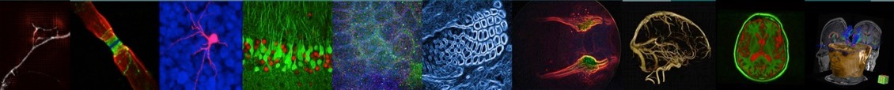
We gratefully acknowledge the generous support of our sponsors:
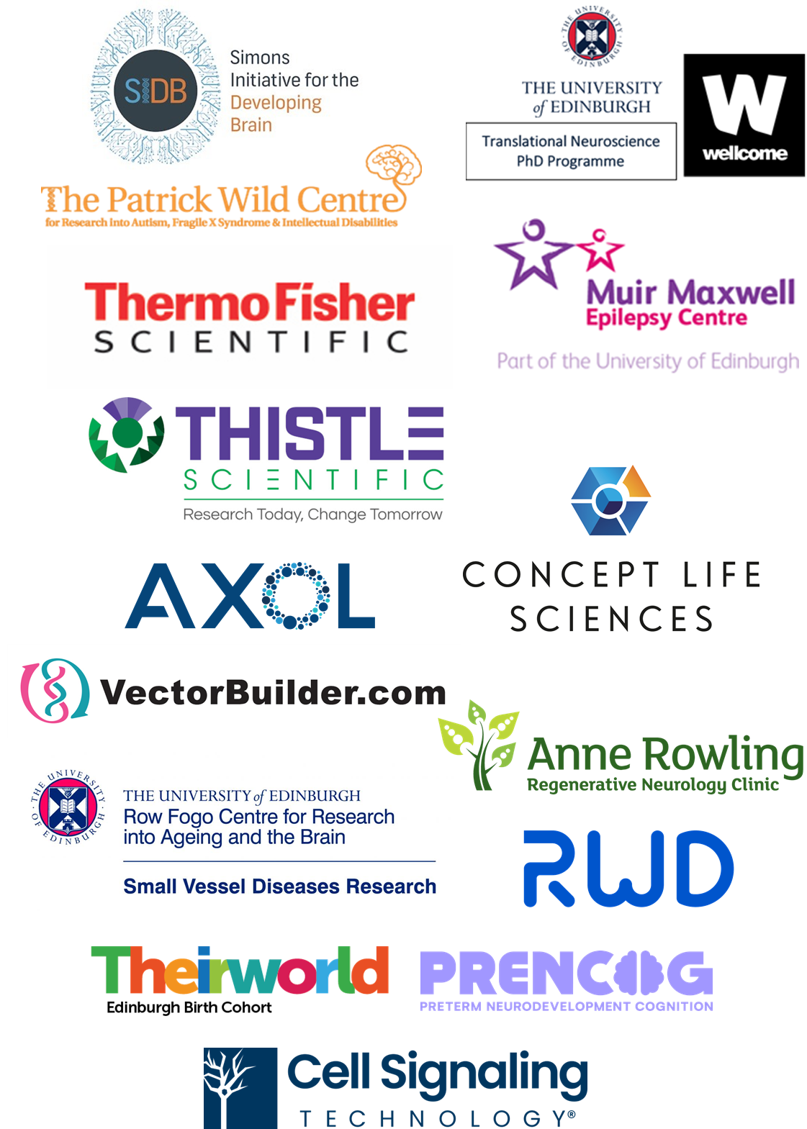

Neuroscience Day 2025 Programme

Wednesday 23 April 2025, Nucleus Building, King’s Buildings Campus, Edinburgh

08.30 Arrival and Registration
Arrival tea/coffee and pastries

Session I

Chair: Prof David Wyllie, Centre for Discovery Brain Sciences

09.15 Welcome remarks from Edinburgh Neuroscience Co-Directors
Professors Cathy Abbott and Malcolm MacLeod
09.25 Shout-outs
Edinburgh Career Development Scheme
Prof Matt Nolan, Centre for Discovery Brain Sciences & CMVM Deputy Dean for Research Management
Biomedical Teaching Organisation
Elizabeth Davenport

09.30 Flash talks from new Group Leaders
Metabolism in motor neuron diseases
Prof Kiterie Faller, Centre for Discovery Brain Sciences
Towards understanding real-world visual cognition with brain-computational models
Dr Benjamin Peters, School of Informatics
All-optical interrogation of the neural code underlying episodic memory
Dr Nick Robinson, Centre for Discovery Brain Sciences
Unlocking the power of predictive processing by reverse-engineering biological neural networks
Dr Nina Kudryashova, School of Informatics
Age-related retinal degeneration: genetics, mechanisms and future therapies
Dr Chloe Stanton, Centre for Inflammation Research
Social and emotional processing in rat models of neurodevelopmental disorders
Dr Sally Till, Centre for Discovery Brain Sciences

10.00 Relevance of tauopathy mouse models in understanding human neurodegenerative diseases
Dr Naruhiko Sahara, Advanced Neuroimaging Center, National Institutes for Quantum Science and Technology, Japan

Chair: Prof Malcolm Macleod, Edinburgh Neuroscience Co-Director
10.15 PhD Student Data Blitz
Development of ultra-high frame rate imaging approaches to investigate circuit mechanisms for memory-related network oscillation
Yifang Yuan, Centre for Discovery Brain Sciences

Unravelling the role of APOE4 in vascular dysfunction and cognitive impairment
Krystal Laing, Centre for Clinical Brain Sciences
Novel Therapeutic Candidates & Behavioural Insights in a Mouse Model of EEF1A2-Related Neurodevelopmental Disorder
Nika Balkic, Centre for Genomic and Experimental Medicine
Epigenetic signatures of perinatal systemic inflammation and their relation to childhood cognition
Rebekah Smikle, Centre for Reproductive Health
Does treating common mental health problems in childhood reduce the risk of severe mental illness in adulthood?
Ioanna Kougianou, Centre for Clinical Brain Sciences (Psychiatry)

10.45 Refreshments & Posters
Session II
Chair: Prof Cathy Abbott, Edinburgh Neuroscience Co-Director
11.30 Emerging Stories
Sensory-driven synaptic plasticity at behaviourally relevant timescales is impaired in a mouse model of autism
Dr Leena Williams, Centre for Discovery Brain Sciences
From Decline to Resilience: New Perspectives on the Roles of Pericytes at the Blood-Brain Barriers
Dr Audrey Chagnot, Centre for Clinical Brain Sciences
Modelling the role of primary cilia in autism spectrum disorders using human cortical organoids
Dr Thomas Theil, Centre for Discovery Brain Sciences
The role of DNA damage and repair in neurovascular heath and disease
Dr Sarah McGlasson, Centre for Clinical Brain Sciences
From hypothesis-free to hypothesis-driven psychiatric genetics
Dr Mark Adams, Centre for Clinical Brain Sciences (Psychiatry)
Utility of Large Animal Models for Biomarker Identification
Prof Tom Wishart, Roslin Institute
Time is brain: pre-hospital diagnosis and treatment of acute neurological disorders
Dr Tom Moullaali, Centre for Clinical Brain Sciences

13.00 Lunch & Posters
13.45 Lunchtime presentation: Concept Life Sciences

Session III

Chair: Prof Peter Kind, Centre for Discovery Brain Sciences
14.15 Responding to homelessness and severe mental illness in Africa with HOPE
Prof Charlotte Hanlon, Centre for Clinical Brain Sciences

SET3 complex dysfunction upregulates active genes in a family of neurological disorders
Dr Matt Lyst, School of Biological Sciences
Insights from the EDIFY programme on pathways into and out of eating disorders
Dr Helen Sharpe, School of Health in Social Sciences, Clinical Psychology
Broadcasting Rules of Entorhinal Cortex Output to the Rest of the Brain
Dr Gülşen Sürmeli, Centre for Discovery Brain Sciences
Better statistical reporting does not lead to statistical rigour: lessons from two decades of pseudoreplication in mouse-model studies of neurological disorders
Dr Constantinos Eleftheriou, Centre for Discovery Brain Sciences

15.30 Refreshments & Posters

Session IV

Chair: Dr Arish Mudra Rakshasa-Loots, BNA Scholar

16.15 Sir Colin Blakemore Memorial Lecture
Building brains and making connections
Prof Laura Andreae, King’s College London

17.15 Drinks reception & Posters

